Created by: David Rubio G.
Blog: https://soceame.wordpress.com/
GitHub: https://github.com/DRubioG
Last modification date: 11/03/25

This is a little-known thing about Microchip FPGAs/SoCs, and that is that they can be debugged using other tools included in the installation. These tools are Synplify Pro (to select the debug signals) and Identify Debugger (to view the debugged signals), both tools developed by Synopsys.
NOTE: these two tools do something similar to the ILA blocks from Xilinx or the Signal Tap Logic Analyzer from Altera. These tools can be opened directly from Libero or from the application itself.
(Previous steps)
This debugging system first requires the user to have synthesized a project in Libero. To do this, click on the Synthesize option.

Synplify Pro
Once we have synthesized the project, we right-click on the Synthesize option and click on the Open Interactively option.
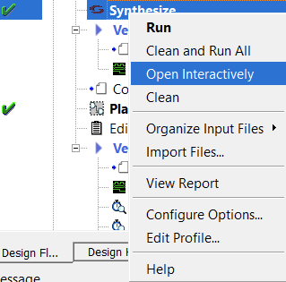
When we click on it, what it does is open Synplify Pro, and when it opens, it shows us this tab.
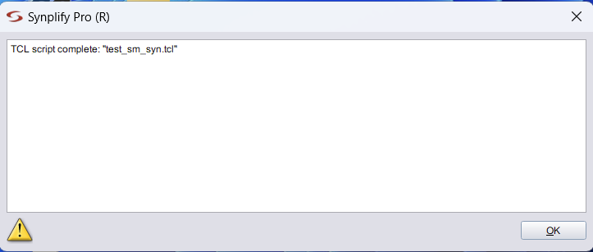
Then a tab opens where our project appears with the synthesis that Libero has done (called synthesis). Well, now what we have to do is create a new synthesis profile that allows us to add the logic analyzers.
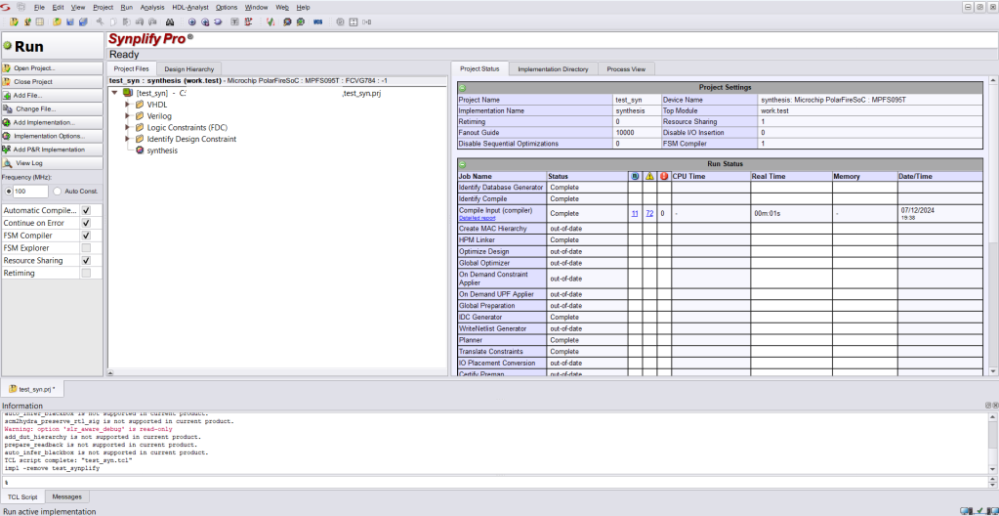
To do this, right-click on the synthesis profile that comes from Libero, and create a new one in New Identify Implementation.
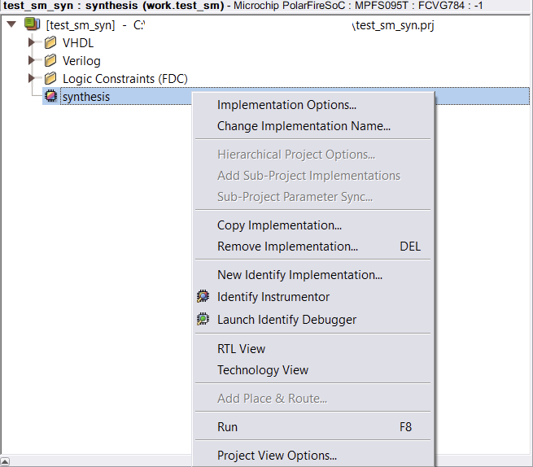
Then, a tab opens that asks us for the name of the new debugging profile and where it will be saved. The Result Base Name is the name of our top development file.
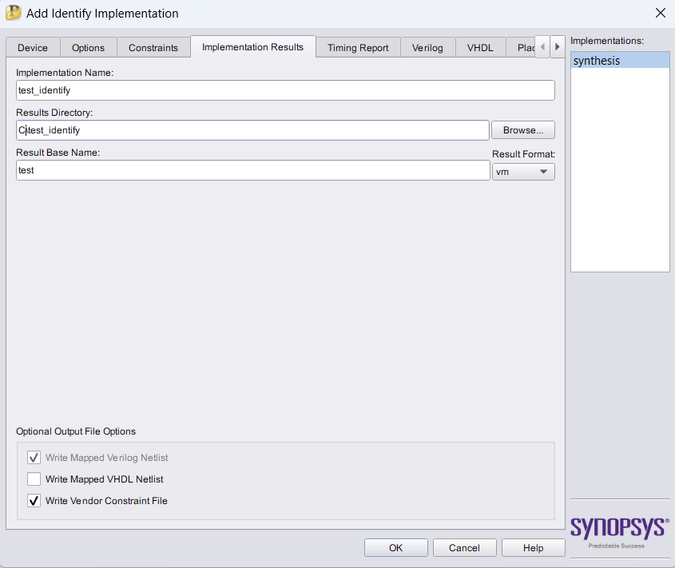
Once the new profile is created, we left-click on the profile, to indicate that we want to use that profile.
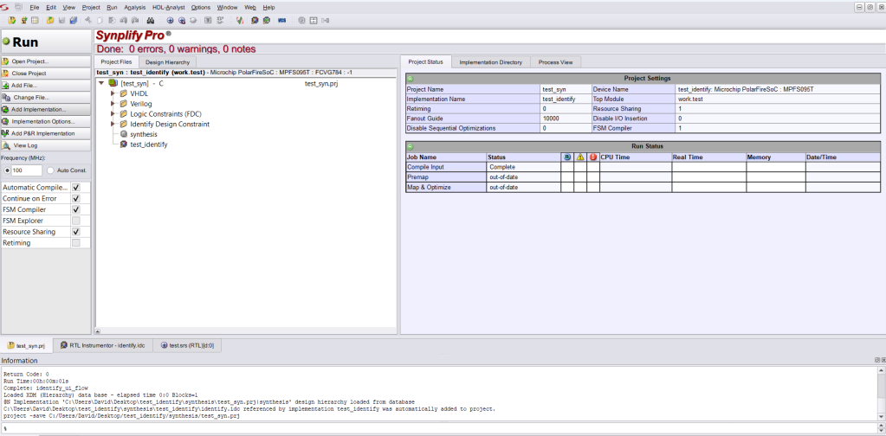
Then, we click on Identify Instrumentor.
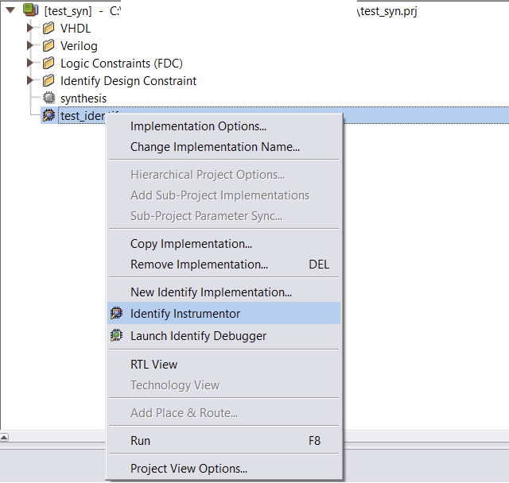
This opens a new tab within the program (so to return to the previous tab you have to go to the bottom).
This new tab is where you have to define the signals that you want to analyze.
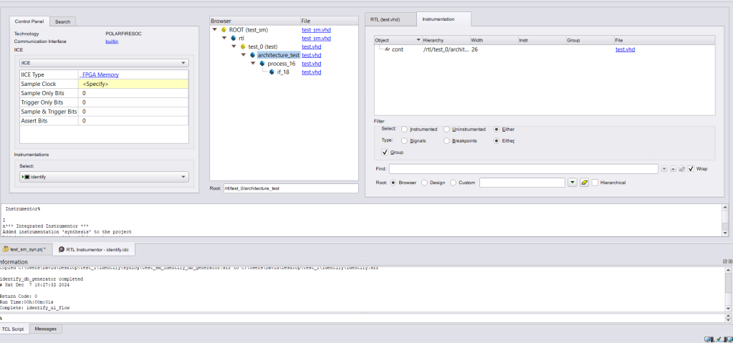
Here, 3 sets of windows appear: the one on the left is the debug groups, which means that you can create different sets of signals to be analyzed in the same debug profile; the tab in the center is where the project structure appears so that the user can choose what to analyze; and the tab on the right is where you choose which signal or port you want to analyze. To do this, when selecting the file in the middle tab, the file appears here with icons for all the signals to be analyzed.
The first thing to do is to create a new signal analysis group (you can also use the default one, IICE).
NOTE: if you do not want to use the default one, it is recommended to delete it.
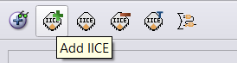
When you click on Add IICE, it asks you for the new set of signals.
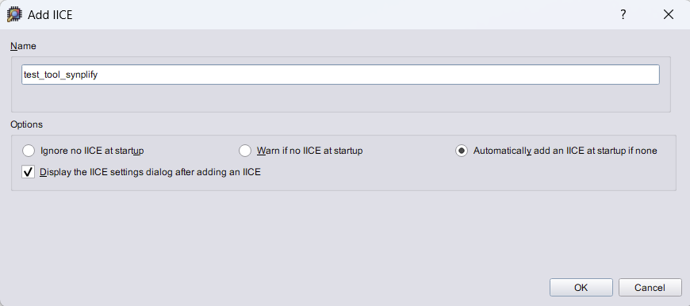
Then a tab opens where it asks you for the memory where the samples will be recorded, how many samples will be saved, the type of clock to be used.
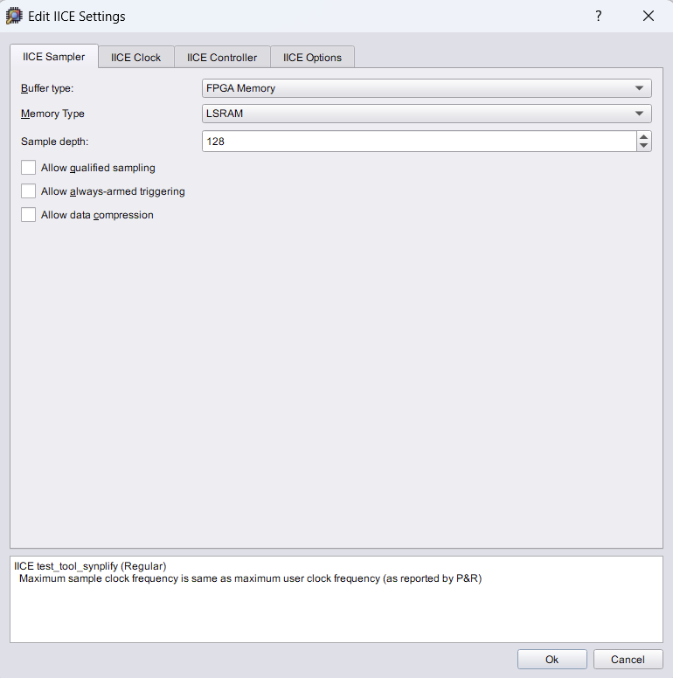
NOTE: it is possible that in Memory Type, if left as AUTO, an error message will appear.
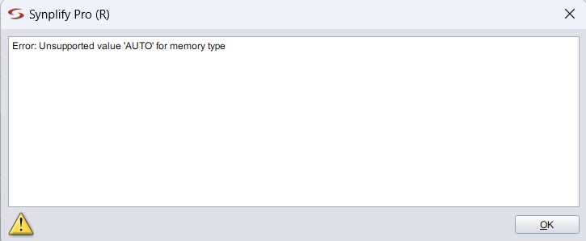
On the left tab we can see the sample sets and the different debugging profiles (this is the Instrumentations option below)
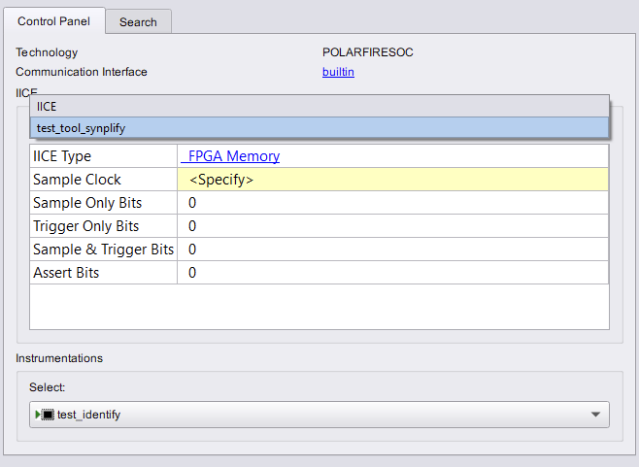
To delete, select the profile and click Delete IICE.
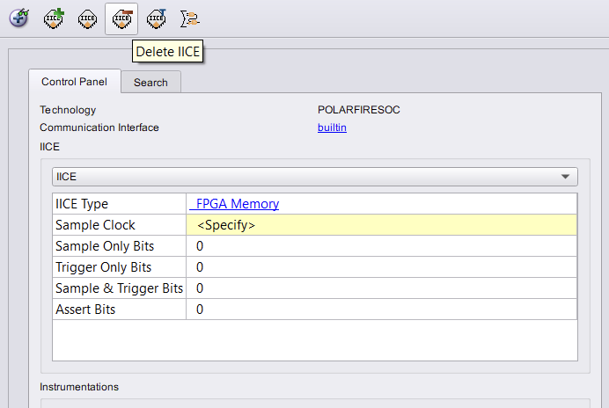
Once the container for the set of signals we want to create has been created, we move on to adding signals.

Reference Clock
The first step for each set of signals in the debug profile is to select the reference clock for that group. To do this, go to the source code on the right (after having selected the file in the center tab) and click on the clock, and a drop-down menu will open, so all you have to do is select the Sample Clock option.
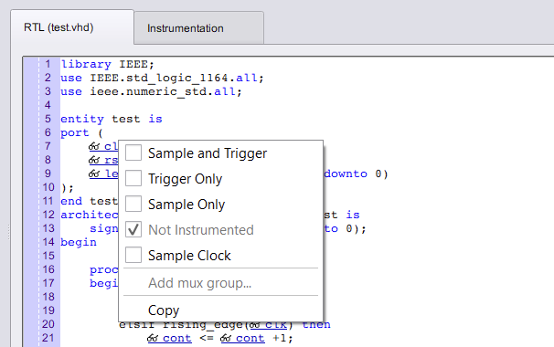
This will make the clock appear as a reference for the set to be debugged (in the left tab).
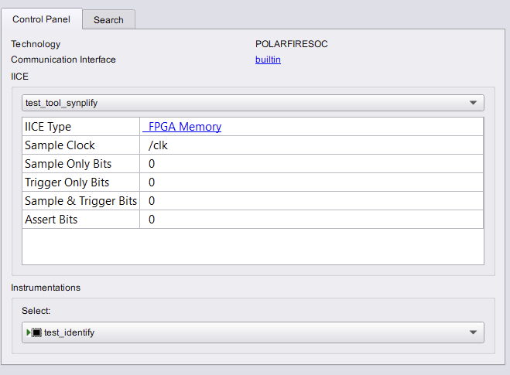
- Selecting signals to be debugged
The next step is to select the signals to be debugged. To do this, just like with the clock, we have 3 options: use the signal as Trigger Only, that is, as a signal that causes the samples to be read at that instant; as Sample Only, that is, as a signal that will be sampled when a change occurs in a signal with a trigger; and as Sample and Trigger, this is the combination of the other previous ones.
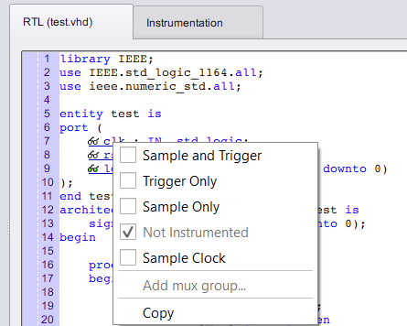
When you finish selecting signals, icons appear for the different signals that will be sampled.
Signal Type | Icon
Sample Clock | Clock
Sample and trigger | Green glasses
Trigger Only | Red glasses
Sample Only | Blue glasses
<Nothing> | White glasses
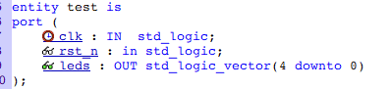
As the number of signals to be debugged increases, so does the Sample & Trigger Bits option.
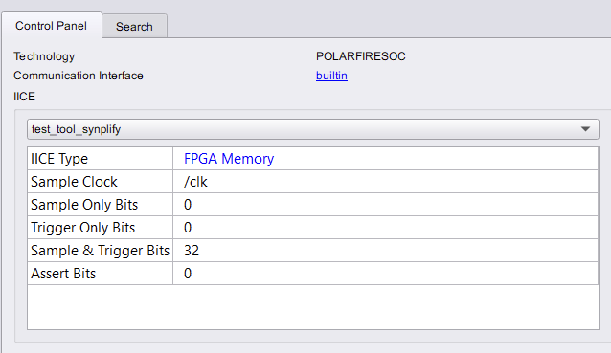
Once we have finished selecting the debug signals we have to save what we have done.
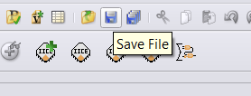
NOTE: The SRS instrumentation view option allows us to view the RTL model of the designed firmware.
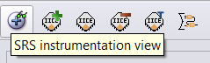
The model would look like this.
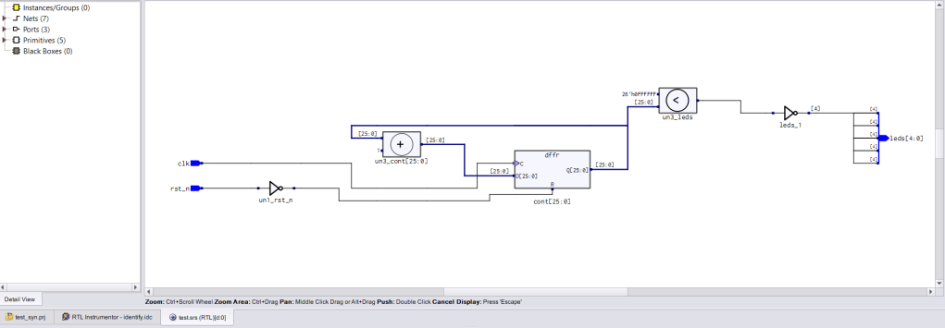
The next step once we have created the set of all the signals we want to see is to return to the main tab
Now we click on the Run option and this will analyze that everything we have done is correct.
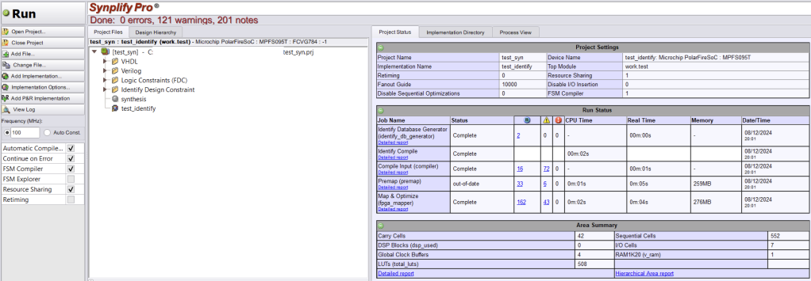
This will cause Libero to update the project behind the scenes but with our changes. Then, we can close Synplicity Pro and return to Libero.
If we now go to the synthesis report generated by Libero, to the option, <project’s name>_compile_netlist_hier_resources.csv, a new field called ident_coreinst appears, where all the consumption of the synthesis generated for debugging appears.
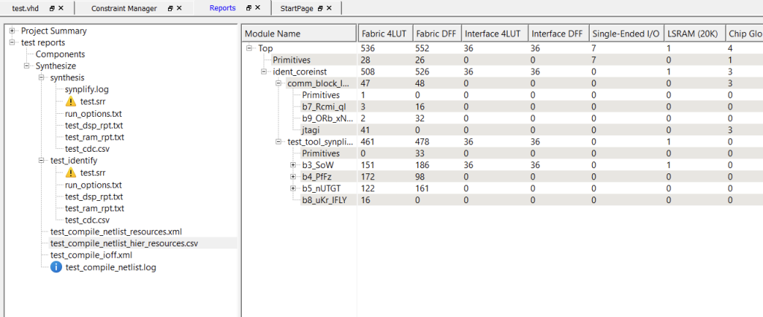
With all this, the next step is to generate a bitstream and upload it to the FPGA/SoC. Remember to generate a pin file to assign the ports to.

Identify Debugger
With all the previous steps generated and a bitstream with the debugging configuration loaded, we move on to the Identify Debugger.
To do this we have to go to the debugging tools and select the one that says Identify Debug Design.
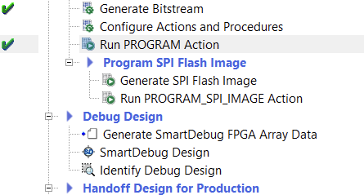
Now the Identify Debugger opens. This tool allows us to view both the signals we have to debug and the way to view them.
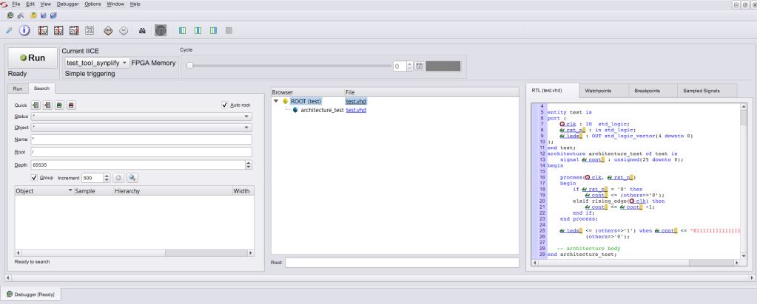
On the left we have the different sets of signals that we can view when launching the debugger.
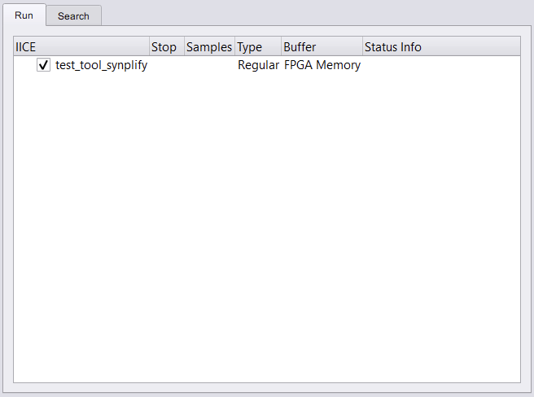
To start, we have to choose which condition the debugger will jump under. To do this, in the tab on the right, in the Watchpoint option, we have to choose which is the trigger and under what condition it is triggered.
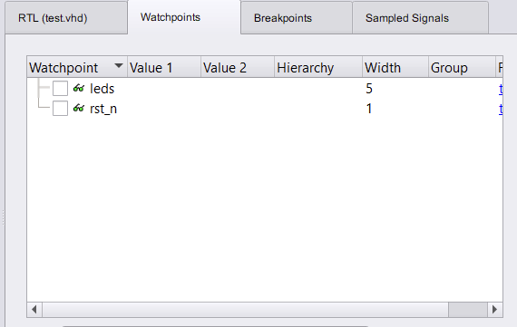
There are two ways to select the trigger form:
- Right click on the signal and on triggering, and select one of the options.
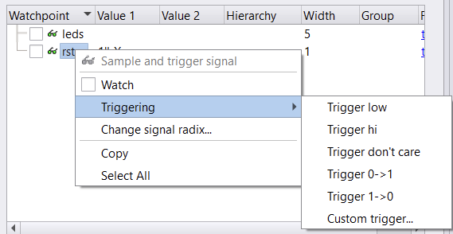
- Double click on the signal, this option is the same as if Custom trigger had been chosen in the previous option.
In the row with the language, it is simply the format in which the trigger condition will be represented.
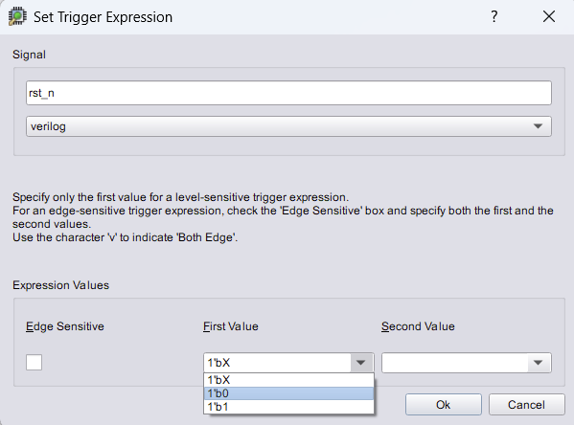
When you finish the selection, you can see the selected condition.
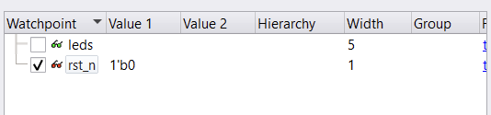
Before launching the debugging, there are several options for the representation of the sampled data, and that is to say that they are aligned to the left, to the right or to the center.
Once everything is selected, you press Run.
NOTE: as many tabs will open as sets of signals have been chosen.
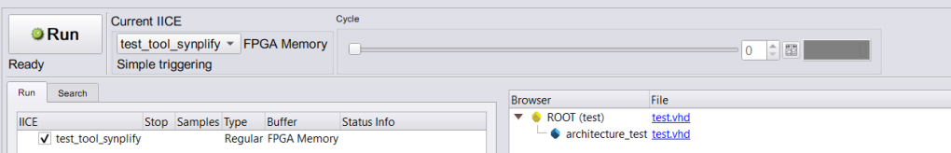
If everything has been done correctly, a tab will open in GTKWave where the signals chosen for debugging are represented.

If you look at the first row, it is the number of samples that have been selected in Synplify, but divided in half, so that you have -52 on the left and 65 on the right.
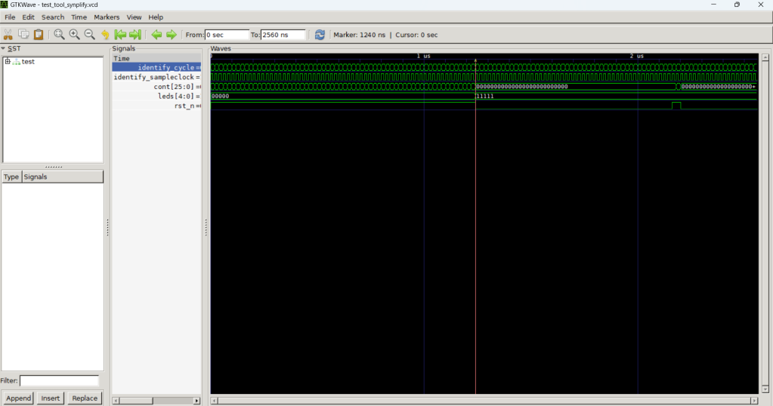
NOTE: If we decide to stop debugging, the debugger asks us if we want to see the last samples it has saved (even if the trigger condition has not been met). This opens a new GTKWave tab with the samples.
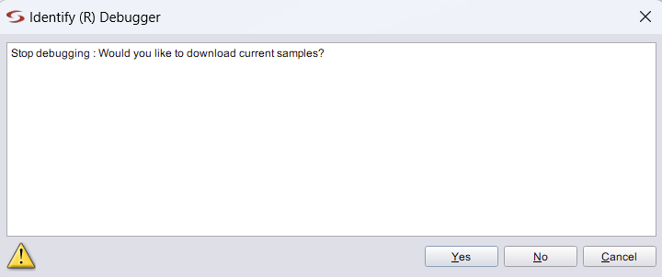
NOTE: as many tabs will be opened as times the debugging is launched.
The signals that are debugged can be saved for later analysis.
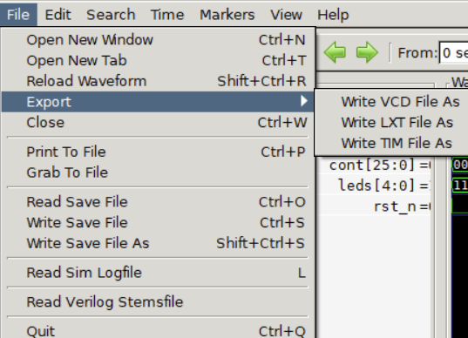
Finally, note that this bar is used to select which sample to place the trigger on to view the signals.
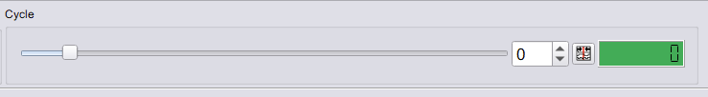

References
https://youtu.be/IiV25OlBLrY

